Addressing Accessibility through Technology: The "Tech for Accessibility" Hackathon

Despite significant technological progress, many individuals with disabilities continue to encounter substantial barriers when it comes to accessing information, services, communication, and daily activities. These obstacles hinder their full participation in society, impacting their independence and overall quality of life.
The Talal and Madiha Zein AUB-Innovation Park at AUB launched the “Tech for Accessibility Hackathon” this summer in collaboration with the Faculty of Arts and Science (FAS), the Maroun Semaan Faculty of Engineering and Architecture, the Office of Information and Technology, the Office of student Affairs, and the Rafic Hariri School of Nursing with support from the Beirut Digital District, Zaka, and Zoho.
This Hackathon aimed to confront this challenge by bringing together a diverse group of individuals with various backgrounds and skills to collaborate and innovative solutions that enhance accessibility for people with disabilities.
We It gathered talented individuals who are passionate about technology and accessibility, aiming to build innovative solutions that showcase their skills, foster collaboration, and compete for a grand prize of $10,500 for the top winning teams.

The hackathon encompassed three distinct tracks and a FAS Challenge:

1. Assistive Technology and Universal Design

Participants collaborated to create inclusive solutions for individuals with disabilities in digital and physical settings.

2. Augmented Reality for Accessibility

Participants used augmented reality to improve accessibility in public spaces and environments for people with disabilities.

3. Accessibility Testing and Remedial Tools

Participants enhanced web services integrating accessibility technologies, designing user-friendly interfaces, and establishing web accessibility standards.

The Faculty of Arts and Sciences Challenge or FAS Challenge

Participants created an MVP (Minimum Viable Product) for a web or mobile solution capable of scanning an area and generating an accessible route for individuals with disabilities. The victorious team was awarded $3,000.

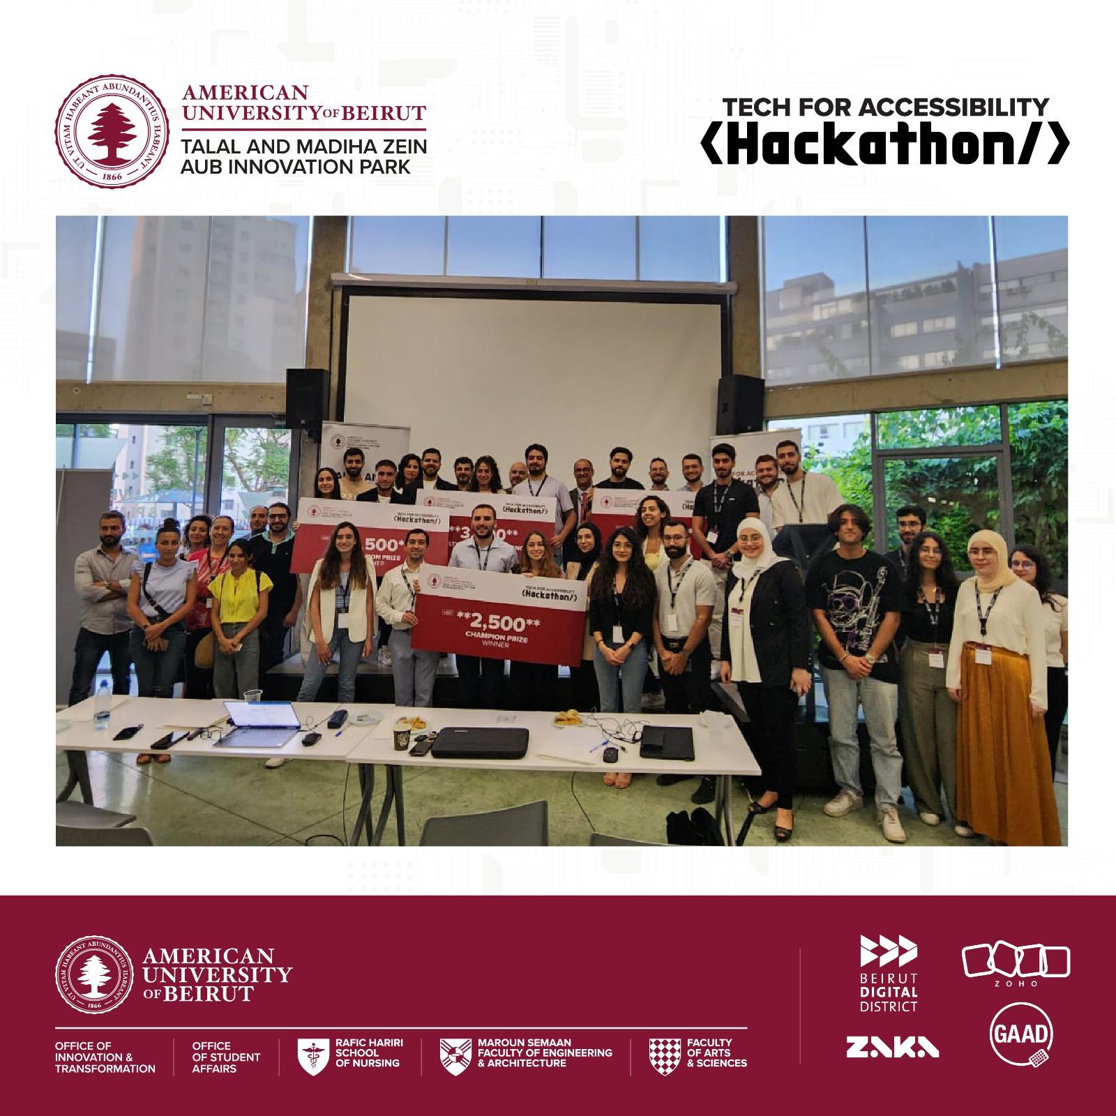
The Mentorship Sessions and Capacity Building workshops proved to be highly beneficial for all participants. Diverse experts from various domains collaborated, generously sharing their knowledge and expertise with the competing teams. The workshops delved into essential topics such as digital accessibility, web accessibility testing tools, pitching ideas, digital product development, business model canvas, and notably, artificial intelligence. These sessions provided valuable insights, equipping the teams with crucial skills and knowledge to excel in the competition and beyond.
Here is an appreciation to all the mentors and judges who have significantly enriched the Tech for Accessibility Hackathon. The invaluable guidance and insightful evaluations provided to participants have been pivotal in fostering innovation and driving positive change for accessibility through technology.

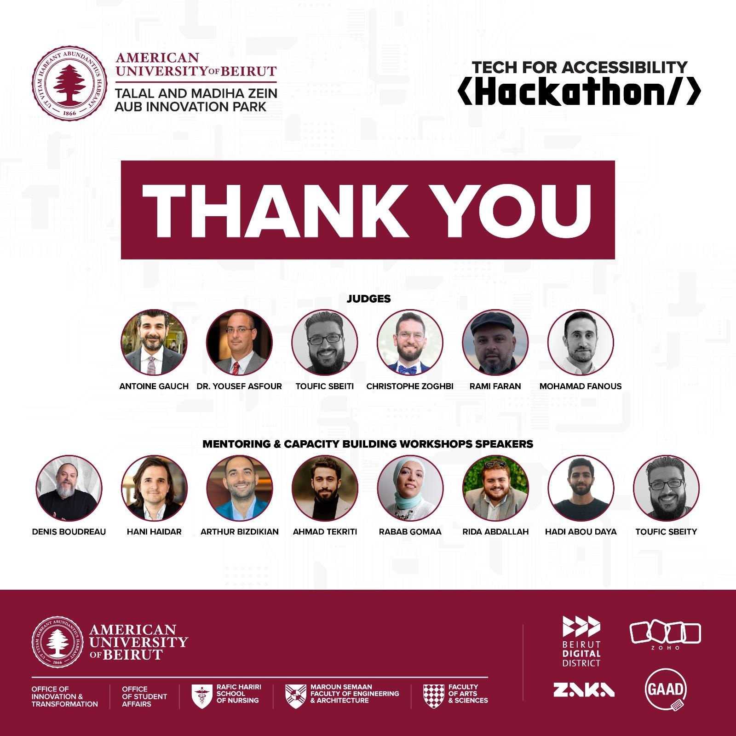
With so many incredible ideas, we bring you those that made it to the final round and got judges on the edge of their seats:

True Vision

The team: Jihad Ftouny, Ali Ammar, Mohammad Harb, & Amir Reza
True Vision is a pair of sunglasses that will enable the blind to be more independent and have more mobility. It uses computer vision to identify objects in front of the user, providing live audio cues for nearby possible dangers or any information deemed useful by the user. The glasses can also be triggered by voice commands, and be customized to specific needs.
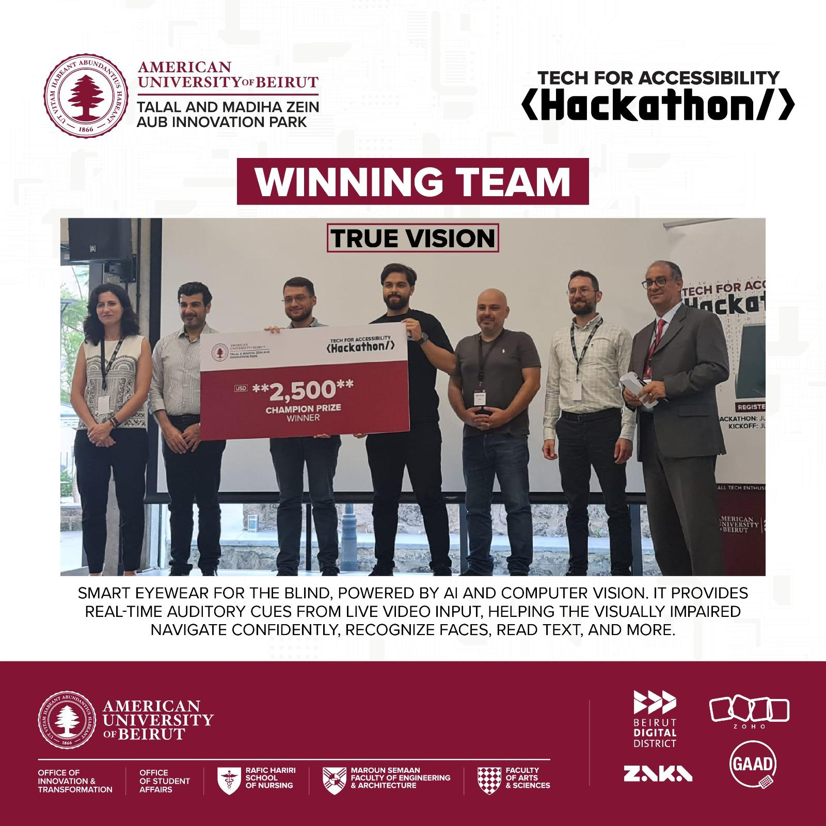

“We registered for the hackathon thinking it would be a great opportunity to quickly develop our skills. We got out of it as one of the champions. It was an intense week, each day everyone was doing a different part of the project. We had so many ideas during the brainstorm sessions and are looking forward to implementing them. The preparation and final days at BDD were very organized, everyone involved was very friendly, and the competition in the air was fiery. Our team True Vision is looking forward to the next ones.” Jihad Ftouny
kalAmI
Samer Chammaa, Zeina Chatila, Maroun Wakim, & Jana Sabra
kalAmI is an AI-driven speech therapy mobile application specifically designed to assist Arabic native speakers who stutter. By providing real-time feedback, personalized exercises, and a supportive community, it empowers Arabic speakers to enhance their fluency, communication, and confidence.
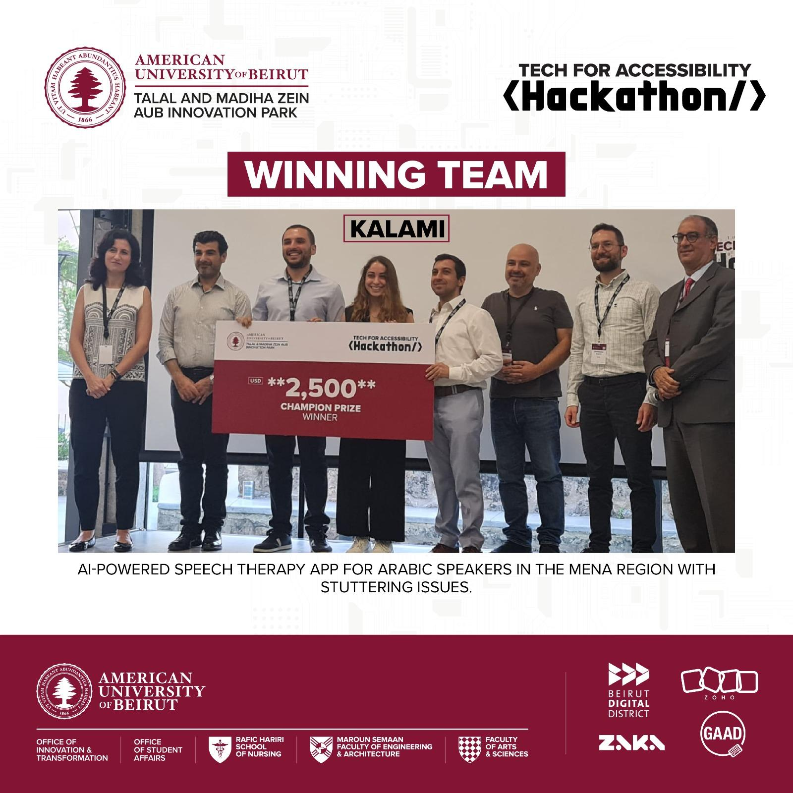
Vision Safe
Hadi Abou Daya, Fatima Mubarak, Karim Doueik, & Joelle El Homsi.
Vision Safe employs advanced AI technology to assist visually impaired individuals with real-time object identification and pathway navigation. Through sound cues and features such as 'frequency' and 'surround sound' modes, users are intuitively guided towards specific objects and given spatial awareness of their surroundings. The application also includes special functionalities like door detection, banknote recognition, and warnings for nearby obstacles, all developed with a strong focus on user safety and accessibility. This technical innovation is coupled with a business model that offers various subscription tiers, making the transformative experience widely accessible.
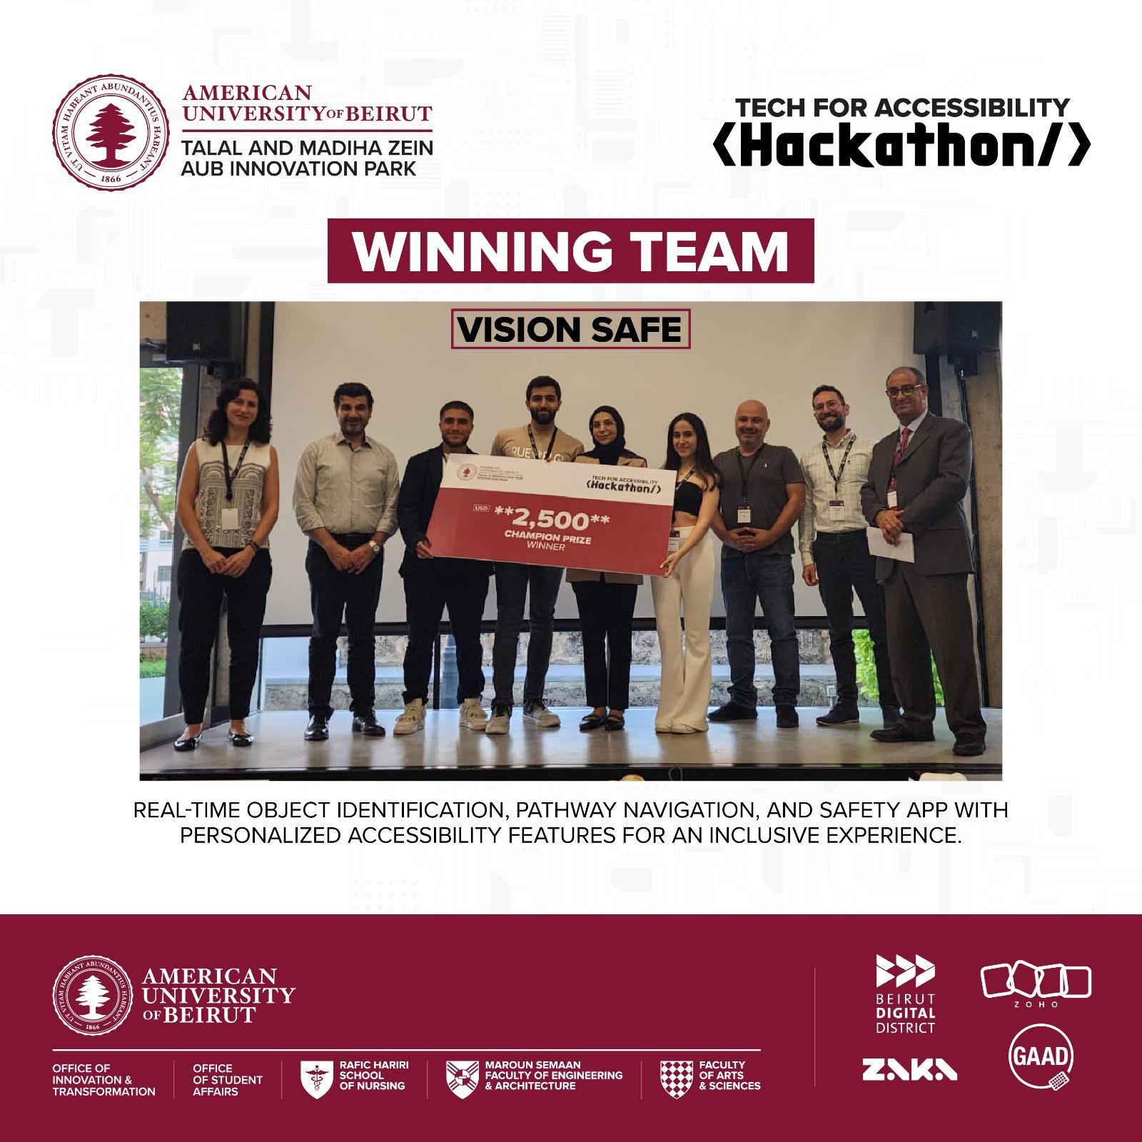

“The hackathon really challenged my AI expertise and my ability to develop a complex solution on the fly. It was a rewarding experience to see our ideas come to life!” Hadi Abou Daya
Navigat-able
Ali Karaki, Wissam Mahmoud, Leen Abdo, & Ola Jouni
Introducing "Navigat-able: Advancing Accessible Navigation through Comprehensive Inclusivity." This visionary initiative embellished with dedication and innovation, redefines conventional navigation paradigms by addressing the distinct challenges faced by individuals with varying impairments. Beyond a mere GPS-based navigation tool, it is a meticulous endeavor aimed at revolutionizing the inclusiveness of the mobility landscape. The project envisages an integrated navigation ecosystem that transcends physical constraints and cognitive barriers, by seamlessly amalgamating cutting-edge turnarounds and state-of-the-art AI tech.
Navigat-able heralds a new era of navigation, encompassing auditory guidance for the visually impaired, spatial awareness cues (cycling routes and ramps instead of stairs) for those with mobility constraints, and context-aware directions for the hearing challenged. This inclusive ethos seeks to empower every individual, irrespective of their limitations, with the freedom to traverse their desired external paths autonomously. The Navigat-able project serves as an emblematic testament to our commitment to universal accessibility, equity, and inclusivity, propelling us toward an era where exploration knows no bounds. With Navigat-able, add the "Ability" In Navigability!
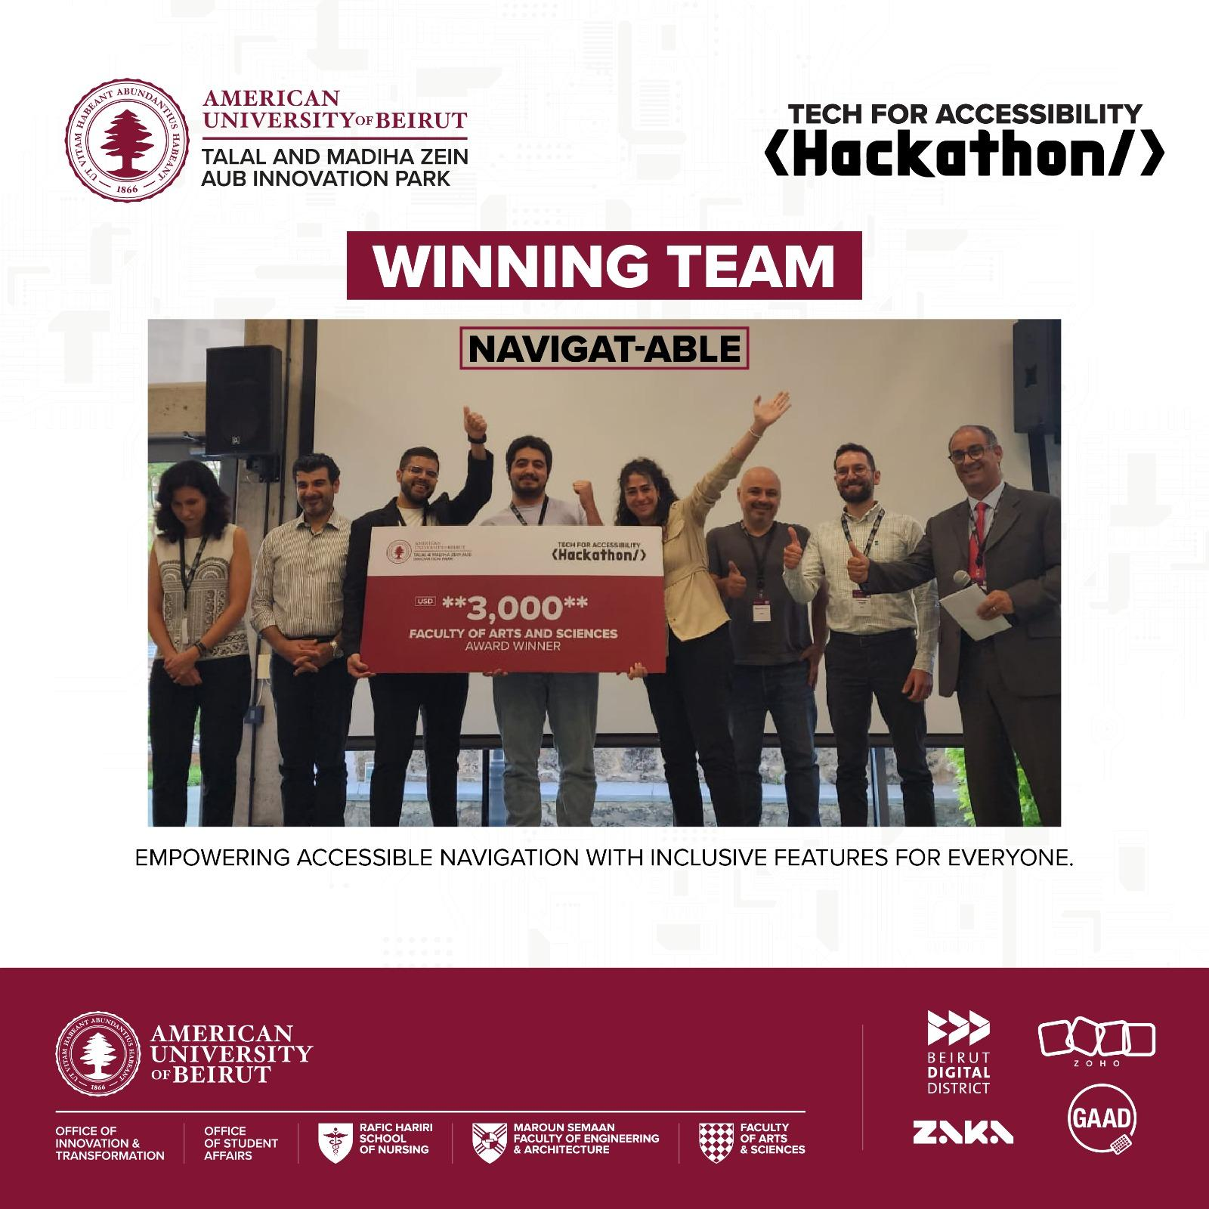

Great job to all the 12 finalist teams! They all worked on making our world more accessible for all. three teams won $2,500 as a prize, and one team won the FAS Challenge of $3,000.
Congratulations to all the finalists and winning teams in the Tech for Accessibility Hackathon. Your dedication, creativity, and unwavering commitment to enhancing accessibility have truly set you apart.
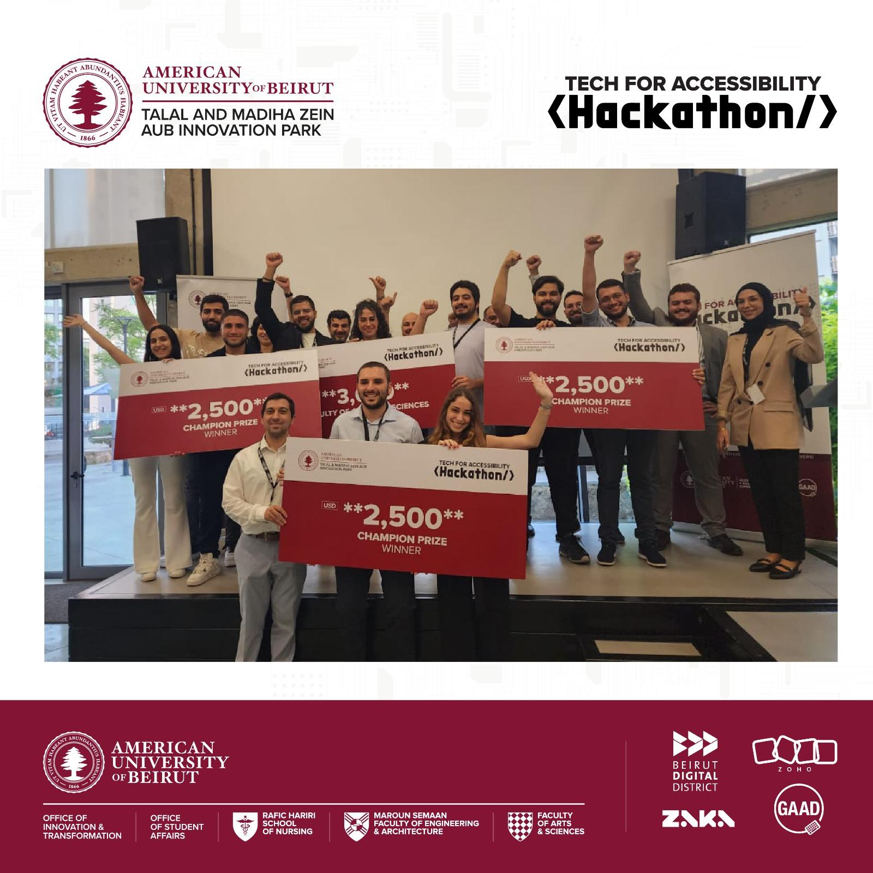
This Hackathon emphasized on the importance of enhancing digital accessibility through hearing stories of inspiring communities, startups, as well as individuals who are contributing to the inclusion of people with disabilities, and most importantly, to give diverse teams the chance to build a socially inclusive community.
Hear it from our community members:
“Working on the project titled "Navigatable" holds profound personal significance to me. The driving force behind my dedication to this cause lies in the real challenges that people with disabilities face on a daily basis. However, the motivation extends even further; it is personal, intimately intertwined with my own experiences with my father, who has been facing visual challenges caused by a chronic hereditary eye disease. Witnessing his struggle and the potential for a complete loss of vision has been both heart-wrenching and awe-inspiring. It has opened my eyes to the immense challenges that individuals with impairments overcome and the strength and resilience they possess. This project is not just a technical endeavor; it is a deeply personal journey driven by compassion, empathy, and the unwavering belief in the need for a more inclusive and equitable world. Through "Navigatable," we are hoping to make a meaningful impact, and empower individuals with disabilities to navigate their lives with greater independence, dignity, and hope.” Wissam Mahmoud

